7 Questions to Ask to Keep Your Teen Safe at Parties
by Parenting Today Staff | on October 22, 2015 | in Activities for Kids, Parenting, Safety Issues
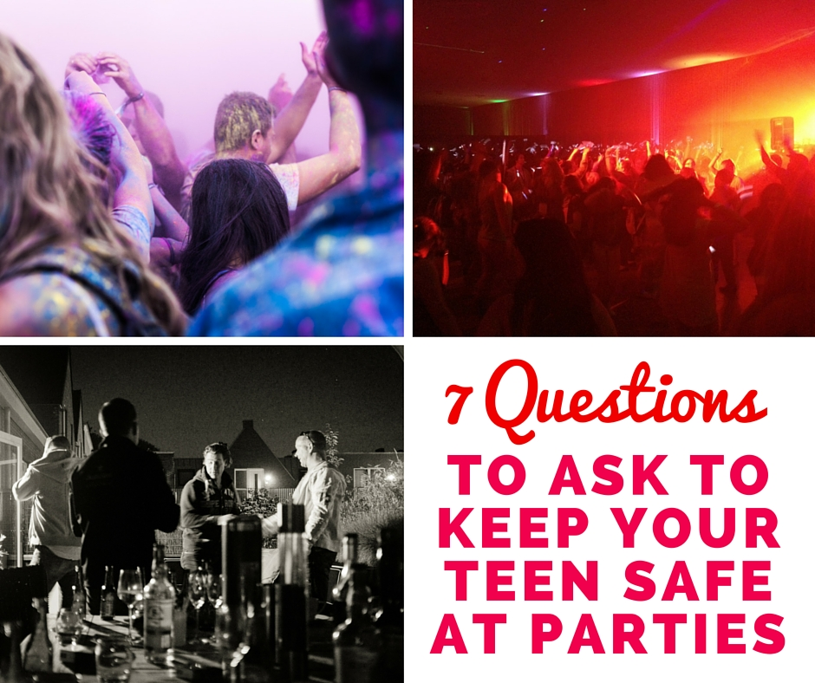
When it comes to raising teenagers, parents will spend a lot of time worrying about where their teens are and what they are doing. The majority of teens will go to parties. Many teens feel like they are practically adults and will be able to handle any situation that may occur at a party. Unfortunately, this is just not the case. Due to the teen’s inexperience they might find themselves in situations that could put them in danger. A parent’s duty first and foremost is to protect their child from harm, and this includes the dangers your child may face when going to a party.
Before saying yes or no, the first thing a parent should do when their teen asks to go to a party is to ask as many questions as they can to obtain all available information about the party, and then if possible verify this information with whichever adult will be responsible for the teens at the party.
7 questions a parent should ask their teen about a party are:
1. Will there be any adult supervision and if so, who will it be?
2. How many teens are attending and will there be any older teens or college students at the party?
3. Are there any activities planned and if so, what?
4. What time does the party start and end?
5. If there are drugs or alcohol at the party, what does the adult supervisor plan to do about it?
6. Will the teens at the party be allowed to come and go from the party as they please?
7. What are the rules of the party?
Unfortunately, there are many parties for teens that have no adult supervision. Drugs, alcohol and sex are present at almost every party without an adult present, and it is a parent’s responsibility to make sure their teen is safe. If a teen insists on going to a party and the parent is unsure if it will be safe due to a lack of information about the party, it is better for the parent to say no until they know more about the party specifics rather than take a risk on their teen’s safety and well-being.
If after talking to the parents of the teen who is holding the party you decide the party seems to be on the up-and-up, before you allow your teen to go you should still talk with them about your expectations. Let them know that there are consequences to their behavior but emphasize that if for any reason they feel unsafe or drugs or alcohol are to be involved they need to call you immediately for a ride home. Teenage parties today are a lot different than the ones their parents used to attend. Not only do teens have the normal party concerns to worry about, they also have to contend with dangers like someone slipping something into their drink. Again, make sure your teen knows to be aware of his or her surroundings and comfortable that they can count on you in any crisis. Making sure your teen is safe is always the top priority.

